Information Pack
Phone, text, WhatsApp, voicemail: 07949 889490
Email: chilterntalkingtherapies@gmail.com
Web: www.chilterntalkingtherapies.co.uk
Please note that these methods of communication are not encrypted.

So you want to know more about Chiltern Talking Therapies, huh?
You’re in the right place!
This information pack explains more about therapy, including expectations of attendance and engagement and terms and conditions relating to payment of services.
If you need any more information, please feel free to contact us.
INTRODUCTION
Chiltern Talking Therapies is owned and run by Miss Jennie Canty, Cognitive Behavioural Psychotherapist.
Jennie has completed a Cognitive Behavioural Therapy (CBT) Masters of Science (MSc) course, is registered with the British Association for Behavioural and Cognitive Psychotherapists (BABCP) - www.babcp.com. You can check her status here: https://www.cbtregisteruk.com/.
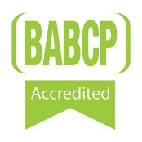
Unfortunately, CBT Therapist is not currently a protected title (like Psychologist is), which means that you can claim to be a CBT Therapist after completing an online course for as little as £30.
CBT Therapists accredited with the BABCP have completed at least 200 client facing hours.
So a little about me (Jennie). Prior to becoming a CBT Therapist, I worked in Prisons, in a variety of different roles and completed Psychology and Criminal Behaviour degrees also. I like to think that I am compassionate and non-judgemental. I have piercings and tattoos and ride motorbikes! For years I have worked with individuals within the Criminal Justice System (both in and out of prison) and with individuals who use substances to cope with life. I hope to make you feel welcome and comfortable throughout our sessions.
I am collaborative, which means that I will not be telling you what to do - I am not a teacher! We will both be equal participants in your therapy. We will combine my knowledge of mental health and CBT, with your knowledge of your situation and history.

I have a valid Disclosure and Barring Service criminal record check and professional indemnity insurance. You can request to see these documents, as well as my qualifications.
And why Chiltern Talking Therapies you ask? I grew up in the Chiltern hills!
COGNITIVE BEHAVIOURAL THERAPY (CBT)
CBT explores the link between your thoughts, feelings, physical symptoms and behaviours. It is an active process which requires a commitment to make changes to your thoughts and behaviours.
You will be given the opportunity to explore your difficulties in a safe, supportive and non-judgemental environment, whilst learning practical coping strategies.
CBT is collaborative and goal focussed, which means that you will not be told to do anything, but you will also not be talking about past problems for the whole session. If you would like to talk about your problems instead of learning practical coping strategies, you would likely suit a counselling approach.
As CBT is an active process, we will agree inter-session tasks, or as we usually call them… ‘homework’. Your homework will usually consist of small, daily tasks, maybe gathering data or practicing techniques and are essential for change. You will be asked to complete questionnaires regularly to monitor your progress.
Following a full assessment of your needs, we will use established, evidence-based CBT methods to help you to develop an understanding of your difficulties before providing feedback and recommendations based on professional observations, specialist training and CBT research.
We will collaboratively develop a treatment plan and estimate the number of sessions required to reach your goals (usually between 6-20 sessions). Your progress and frequency of sessions will be regularly reviewed.
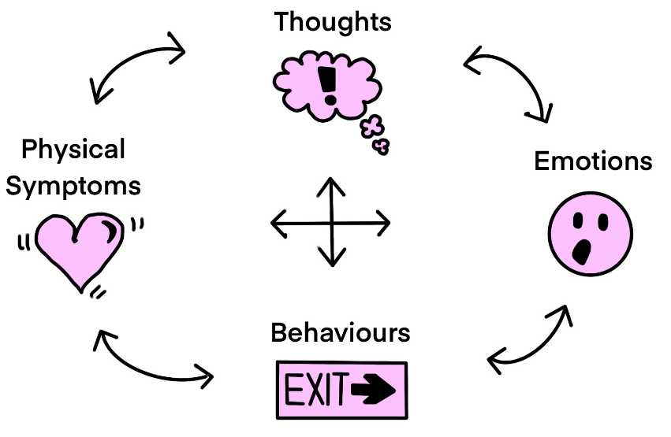
ETHICAL STANDARDS
As Jennie is registered with the BABCP, she is bound by their ethical code of practice. You can view these standards at: www.babcp.com.
In order to maintain high ethical standards, Jennie receives monthly and ad-hoc supervision from a qualified colleague. Trainees receive weekly supervision. This enables Therapists to explore the work completed, the treatment plan, progress or problems, and Supervisors to give advice and monitor that we are completing work to a high standard.
In order to gain or maintain accreditation with the BABCP, your Therapist must keep logs of all client and supervision hours, as well as continued professional development.
THERAPEUTIC RELATIONSHIP
Therapy is built on a good therapeutic relationship. This means, that your Therapist wants to have a good relationship with you in order for your therapy to be as successful as possible.
Although this is the case, we also need to set some boundaries to ensure the relationship stays professional and to protect your confidentiality.
Your Therapist will be on a variety of social media platforms, both publicly and privately. To maintain a good therapeutic relationship, your Therapist will not accept friend requests on private social media accounts.
You are welcome to add and engage with us on our business accounts however please be aware that these platforms are not secure, so you should not share personal details via direct messages.
We always strive to maintain your confidentiality, but if you post publicly, for example by commenting on a social media post, other people could see this. In these circumstances, we may generically respond to you which may feel a bit strange. If we bump into each other in public, we will not acknowledge you unless you acknowledge us.
Your Therapist will not search for you on social media without your consent, or unless it is part of an agreed treatment plan.
You should also never contact your Therapist in a crisis, in case they are unable to respond.

APPOINTMENTS
To get the most out of therapy, sessions should be scheduled weekly or fortnightly to benefit from momentum.
Appointments can be offered on certain days or evenings, and will usually last between fifty to sixty minutes, though could be up to ninety minutes when required.
Therapy can be conducted in a variety of different ways. You can choose between face to face, video (e.g. Zoom) or telephone.
Face to face appointments are available and will follow COVID-19 social distancing guidelines.
So that you can get the most from therapy, you should not attend if you are intoxicated.
REMOTE THERAPY
In order for remote therapy sessions to be effective, you will need to treat them like a face to face session; e.g. making sure that you are in a space where you will not be disturbed for the duration, with your phone on silent, and able to speak freely and confidentially.
You will need to be able to email or text your homework assignments and use the agreed method of communication, e.g. Zoom.

CONFIDENTIALITY
Your attendance and the content of your sessions will be kept confidential.
Your Therapist will keep some clinical notes about our sessions, your presentation, homework and risk which will be kept confidential and will be destroyed after therapy. You are assigned a code (e.g. JC1) and documents are password protected.
You may decide that you are happy for your Therapist to discuss your appointments with someone else. If this is the case, your Therapist will ask you to put this in writing with their contact details.
We will ask you for your GP’s contact details. This is so that we can inform your GP about concerns relating to your risk to self (e.g. thoughts that you would be better off dead or of hurting yourself in some way).
The only circumstances where we may divulge confidential information is if we believe that you present a potential risk to yourself or others. This includes suicidal thoughts, crimes, or safeguarding concerns. We will aim to discuss with you, but this may not be possible and we retain the right to discuss concerns without consent.
Your Trainee Therapist will be discussing your case with Jennie (their Clinical Supervisor) weekly. Jennie also maintains your confidentiality. As part of their University course, your Trainee Therapist may discuss your case in supervision or written work, but all personal details will be omitted.
RISK MANAGEMENT PLAN (RMP)
We have a responsibility to monitor risks to you and others. Although your Therapist will be there to support you, throughout therapy you are expected to follow an agreed RMP which will be created collaboratively.
If you are unable to manage your own risk, we will discuss whether now is a good time to engage in therapy. If you disclose risk to yourself, your Therapist will contact your GP to ask them to also support you.
You should not contact Chiltern Talking Therapies in a crisis as we may not be able to respond.
Here is an example RMP:
If my mood or symptoms deteriorate, I agree to the following risk management plan:
- To contact my GP and request an urgent appointment.
- To call the Samaritans on 116 123 (available 24/7).
- To text the Shout crisis text line by texting ‘shout’ to 85258 (available 24/7).
- To contact my local crisis team.
- To go to A&E, or if I cannot get there safely, to call 999.
FEES
The current fees are set out below:
30-minute consultation prior to therapy commencing: Free
60-minute session: £70 (Qualified) / £40 (Trainee)
60-minute session: £105 (Qualified) / £60 (Trainee)
Prices are subject to change.
PAYMENT
Payment for sessions is to be made in advance. You can make payment by cash (if in person) or bank transfer. Cheques are not accepted as payment.
CANCELLATIONS
If for any unforeseen circumstances it becomes necessary to cancel an appointment, we will endeavour to provide you with a minimum of 48 hours’ notice. You may hear from your Trainee Therapist or their Supervisor (Jennie).
You will be required to attend all booked appointments promptly and at the date and time agreed. If you are unable to attend an appointment, you must also endeavour to provide 48 hours’ notice by calling or texting 07949 889492 or emailing chilterntalkingtherapies@gmail.com.
If you provide less 48 hours’ notice, you agree to pay a remittance of 50% of the agreed session costs and if you provide less than 24 hours’ notice, you agree to pay the full session cost.
If you would prefer to move from face to face sessions to remote sessions, please provide your Therapist with 14 days’ notice.
If you need to cancel lots of sessions due to unforeseen circumstances, we will discuss whether this is the right time for you to engage in therapy.
DIFFICULTIES
In the first instance, you should discuss your concerns with your Therapist. Your therapy can be adapted and your Therapist will always be happy to receive feedback.
If you would like to end therapy for any reason, please make your Therapist aware so that you can work towards and ending. This might include referral or signposting to another therapist or service.
If you would like to discuss concerns about your Trainee Therapist, you can contact Jennie at any time on 07949 889 492. If you would like to transition to working with a qualified Therapist instead, that is not a problem, you are allowed to change your mind, please let us know.
If you have any cultural, literacy, or any other needs, please make your Therapist aware so that they can adapt sessions accordingly.
CBT is time limited. You should not be receiving CBT for years, instead your Therapist should be preparing you for ending and utilising coping strategies independently.
As has already been highlighted, CBT is an active therapy. Please do not expect change to happen if you are not making changes, are not completing homework, or not being completely open in sessions. If you are not ready to engage in CBT at this point in your life, that is ok.
If you wish to make a complaint about your therapist, you can contact the BABCP.
ENDING THERAPY
You are free to end therapy at any time, although it is recommended that this is planned for. Toward the end of therapy, your progress can be evaluated and a Relapse Prevention Plan will be created. This is designed to consolidate your knowledge and give you something to refer back to after treatment.
If your Therapist has concerns about your ability to engage in therapy, this will be discussed with you and a plan will be put in place. This plan might involve referring you to another Therapist, or signposting you to an appropriate service.
If you would like to give feedback on your experiences, this would be greatly appreciated to improve your therapist’s practice and future client experiences.
If you would like to give feedback about the service, please use this link - https://www.smartsurvey.co.uk/s/MOCHK1/
WORKING WITH A TRAINEE CBT THERAPIST
Chiltern Talking Therapies offers Trainee CBT Therapists the opportunity to practice with suitable clients. Trainees are attending University and working toward their accreditation to become a Qualified CBT Therapist.
Our current Trainee CBT Therapist (Inga) is a qualified Art Psychotherapist, but is training in a new method of therapy – CBT.
She has completed over 100 hours of individual CBT practice to date and requires 200 hours to pass her postgraduate University course and qualify as a CBT Therapist.
Trainees are heavily supervised by Jennie (qualified CBT Therapist and Owner of Chiltern Talking Therapies). They will have one hour of supervision per week, plus ad hoc supervision.
When working with a Trainee CBT Therapist, sessions are usually audio recorded. This is not mandatory, but helps to develop the Trainee’s skills.
Audio recordings are played in Supervision in order for the Qualified CBT Therapist to listen to the Trainee CBT Therapist and give feedback. The purpose of this Supervision is only to monitor ethics and CBT practice, as well as giving feedback on the Trainee CBT Therapist’s style. The client is not the focus of these Supervision sessions, instead this is to support the Trainee’s practice and sign off the required skills, knowledge and attitudes.
With regard to confidentiality, the only person the Trainee CBT Therapist will discuss your case with is Jennie. Jennie may choose to discuss your case with her Clinical Supervisor. The only reason we would break confidentiality outside of our Supervision structure is in case of risk.
Your difficulties appear suitable to work with a Trainee CBT Therapist, though if this changes you will be transferred to working with Jennie, or another suitably qualified Therapist, to ensure your needs are met.
If you change your mind and do not want to work with a Trainee CBT Therapist, or no longer wish to be recorded, this is absolutely fine, please let us know.
If you have any concerns about your Trainee CBT Therapist’s practice, you can contact Jennie directly on 07949 889 492 or chilterntalkingtherapies@gmail.com.
Due to working with a Trainee, the cost of therapy will reflect this. The cost for working with Inga is £40 per 50-60 mins.
Please take your time to consider this decision and feel free to contact Jennie to discuss further. If you would like the opportunity to speak to our Trainee (currently Inga) before committing to working with her, please let us know and we will arrange a free 30 minute consultation.

